

MEMORANDUM

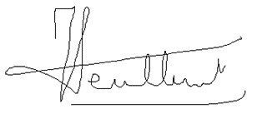
TO: Unit Heads

FROM: Jean-Francois Meullenet
Director, Agricultural Experiment Station

John Anderson 
Director, Cooperative Extension Service

DATE: February 1, 2024

SUBJECT: Initiation of Research Incentive Grants Program

The Research Incentive Grants (RIG) Program is designed to give early career investigators an opportunity to generate proof-of-concept, preliminary data, or explore emerging areas of research. Funds will be used to leverage extramural grants and contracts. Participants must identify further funding opportunities to be competitive for RIG.

All early career faculty with an appointment in the Agricultural Experiment Station or the Cooperative Extension Service will be eligible to apply for RIG funding. Early Career is defined as faculty in the first seven years of employment who have a research appointment with the Arkansas Agricultural Experiment Station or an extension appointment with the Cooperative Extension Service. A faculty member can only be awarded RIG funding once.

Investigators are invited to submit one proposal electronically in PDF format following the attached guidelines and template. The call for proposals will be issued from the AES and CES Directors’ offices February 1 each year, with a submission deadline of March 15. Proposals must be submitted to the faculty member’s departmental assistant/administrative manager to upload to the Box file.

The naming convention is: RIG_2024_LastName, FirstInitial_DEPT

If you have questions, feel free to contact us.

Thank you.

